National Autism Awareness Day
April 2^{nd,} 2017
Since April 2nd lands on a Sunday, WLES will be honoring this day On Friday, March 31st, Willis Lane Elementary will be wearing blue in support of National Autism Awareness Day! We strongly encourage you to send students in any shade of blue!
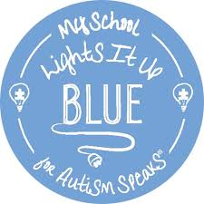
During your child’s Co-Curr class on March 31st, we will be walking outside in honor of Autism Awareness. Please feel free to join us during your child’s designated Co-Curr time to walk with your child and help support Autism Awareness.
8:15 – 9:10: 3rd gr.
9:15 – 10:10: 2nd gr.
10:15 – 11:10: 4th gr.
12:45 – 1:40: Kind.
1:45 – 2:40: 1st gr.

*But please note, if you are coming to watch or walk with your child you will need to sign in with the front office first.

